

Oklahoma Recycling Association Annual Recycling Conference
The Oklahoma Recycling Association (OKRA) will hold a virtual conference, “Staying Green in Quarantine!” on Wednesday, October 7th and Thursday, October 8th. The sessions will start on Wednesday afternoon and continue Thursday morning, until adjourning at 12:30 p.m.
“We know this has been an extraordinary year for everyone,” said OKRA President Sara Ivey, “and the recycling industry is no exception. We are excited to have people from all over Oklahoma come together to share how they are overcoming the challenges of Covid-19, and we will hear from some national experts on how the country is coping with our ‘new normal’.”

Internationally known speaker, Chaz Miller, former Director of Policy & Advocacy for the National Waste and Recycling Association, will deliver Wednesday’s keynote address on “National Sword and the Pandemic: What Next for Recycling.” President of the Global Product Stewardship Council and Chief Executive Officer and Founder of the Product Stewardship Institute, Scott Cassel, MCP, and Senior Associate of Policy and Programs Rachel Pearlman, Ph.D. will deliver the keynote address Thursday on Extended Producer Responsibility (EPR). They will talk about what EPR is in general, in Oklahoma and in plastics and plastics pollution.
Other conference topics include Municipal Challenges During and After COVID-19, Market Update, and Finding Ways to Recycle Glass in Oklahoma. There will be opportunities to talk with experts in four different roundtable discussions (breakout rooms) on Food Waste, Batteries, E-waste and Glass. Conference attendees will have the ability to participate in two different sessions. The OKRA Conference agenda can be found on the events page on the OKRA website at www.recycleok.org.
There will be a special networking time at 6:00 p.m. on Wednesday, October 7th, with Michael Patton. Also known as Recycle Michael, Patton will do a little stand-up comedy as well as facilitate a conversation on topics of interest to the group. This session is free of charge, but you will need to register to participate.
Attendees may register for one or both days. Registration for OKRA Members is $10 per day. For non-members, registration is $20 a day. This year OKRA will have a new category for teachers and classrooms to participate. A group (class) rate will be available for $15 a day. To register for the conference go to: 2020RecycleOK.eventbrite.com
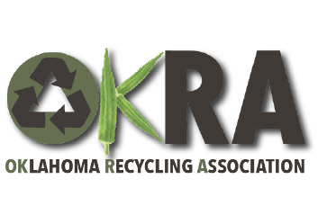
This event is sponsored by the Oklahoma Department of Environmental Quality, Chickasaw Nation, Indian Nations Chapter of SWANA, and Crafting Wood for a Better World. Conference supporters are: Oklahoma Green School Programs, Oklahoma State University Cooperative Extension, Pinpoint Wire Technologies and Ripple Glass. Additional support is welcomed! For support level information, please contact info@recycleok.org.

