For Immediate Release: Media Contacts:
November 6, 2013 Jennifer Hamilton
813-775-6211
Jennifer.Hamilton@hkstrategies.com

REmember CARTONS THIS AMERICA RECYCLES DAY
Consumers already know cartons are recyclable and an extremely environmentally friendly package
VERNON HILLS, Ill.—This November 15 on America Recycles Day, the Carton Council of North America urges recycling coordinators everywhere to remember cartons in their resident education outreach.
“Residents want recycling to be as easy as possible and that means accepting as many materials as possible—including cartons,” said Jason Pelz, vice president, environment, Tetra Pak North America, and vice president of recycling projects for the Carton Council of North America. “Having cartons as an accepted material in a recycling program will bring greater convenience to residents and help move communities closer to achieving Zero Waste and sustainability goals.”

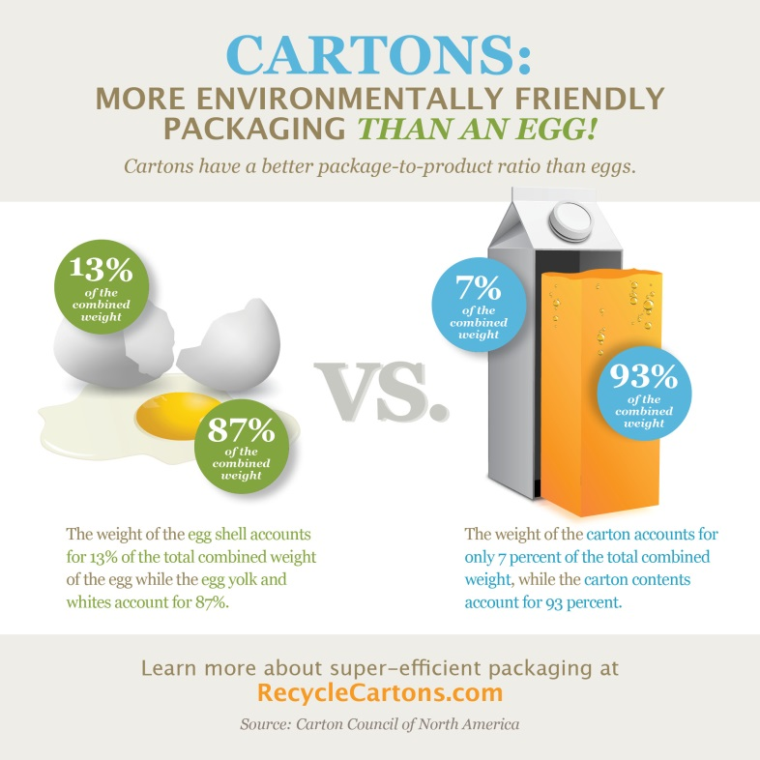
In fact, many Americans already know cartons are recyclable. A recent survey commissioned by the Carton Council revealed that overwhelmingly, Americans believe that the food and beverage cartons they see on store shelves are recyclable, making it imperative for communities that do not yet accept cartons to add access and for those that do to promote recycling cartons to their residents. The survey showed that 77 percent of respondents said they believed cartons to be recyclable after being shown an image of them.
“We are encouraged by these findings and motivated to continue to grow access and infrastructure for recycling cartons across the country,” said Pelz. “And access to carton recycling is growing fast, with 46 percent of U.S. households now able to recycle cartons through their curbside and drop-off recycling programs.”

Cartons are an extremely environmentally friendly package, more so than even an egg! Made mainly from a renewable resource, cartons are lightweight and compact in design, and have a low carbon footprint, which gives them a high package-to-product ratio. That means when purchasing food and beverages packaged in cartons, consumers receive more of the product they want and less of the package. This also justifies cartons as their own category in lists of accepted materials that communities promote to their residents.

The Carton Council currently has a campaign designed to help counties, municipalities and recyclers bring carton recycling to their residents. For more information, visit CartonOpportunities.org.

ABOUT THE CARTON COUNCIL
The Carton Council is composed of four leading carton manufacturers, Elopak, SIG Combibloc, Evergreen Packaging and Tetra Pak, as well as an associate member, Weyerhaeuser. Formed in 2009, the Carton Council works to deliver long-term collaborative solutions in order to divert valuable cartons from the landfill. Through a united effort, the Carton Council is committed to building a sustainable infrastructure for carton recycling nationwide and works toward their continual goal of adding access to carton recycling throughout the U.S. For more information, visit CartonOpportunities.org.

# # #

