For Immediate Release: Media Contact:
November 6, 2013 Jennifer Hamilton
813-775-6211
jennifer.hamilton@hkstrategies.com

new survey reveals americans overwhelmingly believe cartons are recyclable
Survey results reflect the continued and growing need for more communities to accept cartons in their local recycling programs

VERNON HILLS, Ill.—For the countless communities across the country that are looking for ways to make their recycling programs more convenient and robust for residents, a recent survey provides further evidence in support of adding carton recycling. The survey, which was conducted by Research Data + Insights on behalf of the Carton Council of North America, included 1,000 adults from across the country. Findings revealed that overwhelmingly, Americans believe that the food and beverage cartons they see on store shelves are recyclable, lending even more reasons for a community that does not already accept cartons to begin doing so.

The survey, conducted in September 2013, indicated that 77 percent of respondents, after being shown the below images of cartons, said they believed these packages to be recyclable.

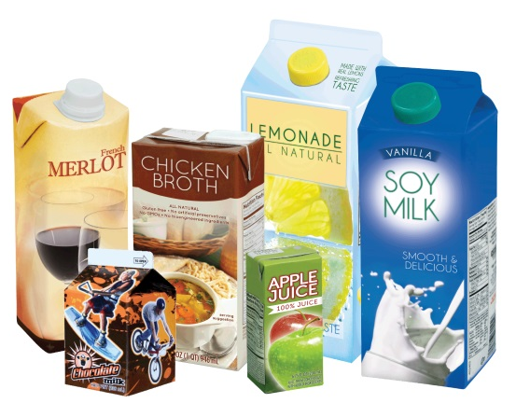
“When a consumer believes an item is recyclable and purchases that item, their next natural question is going to be: where can I recycle this?” said Jason Pelz, vice president, environment, Tetra Pak North America, and vice president of recycling projects for the Carton Council of North America. “Communities must give residents a way to recycle everyday items like food and beverage cartons, especially if they want to continue to see growth in their programs.”

Pelz continues, “Our research reiterates that consumers know that cartons are recyclable. Sixty-four of the 100 largest U.S. cities are part of the carton recycling movement already. We want the rest. The progress we have made in increasing access to carton recycling, a 150 percent gain in just four years, is indicative of the increasing awareness around the recyclability of cartons as well as the value they provide to a community or facility through their strong and hungry end markets.”

According to the survey, Americans also believe the product and packaging industry plays a key role in the recycling of their products. The survey found that a clear majority (86 percent) expect food and beverage brands to actively help increase recycling of their packages.

“We have long recognized the need for private-public partnerships to help us meet our recycling goals,” said Pelz. “A community doesn’t need to be alone. This is why we formed the Carton Council in 2009, and why a core focus of ours has been on working side by side with communities, facilities and schools to make carton recycling efficient and available.”
The Carton Council of North America, who is working to deliver long-term collaborative solutions in order to divert valuable cartons from the landfill, recently announced that a new milestone had been reached. Forty-five percent of U.S. households can now recycle cartons through their curbside recycling programs and other recycling venues, thanks to a unique voluntary private and public collaboration that includes industry, recycling facilities and local governments.

In 2009, 21 million U.S. households had access to carton recycling in 26 states. Now, 52.5 million households in 45 states can recycle cartons, including residents in cities such as New York, Los Angeles, Philadelphia, San Antonio, San Diego, Dallas, Milwaukee and Denver.

The Carton Council currently has a campaign designed to help counties and municipalities, as well as recycling facility operators, bring carton recycling to their residents. More and more material recovery facilities are accepting cartons. To find out if yours is, or to learn how you can bring carton recycling to your community, visit CartonOpportunities.org.

###

ABOUT THE CARTON COUNCIL
The Carton Council is composed of four leading carton manufacturers, Elopak, SIG Combibloc, Evergreen Packaging and Tetra Pak, as well as an associate member, Weyerhaeuser. Formed in 2009, the Carton Council works to deliver long-term collaborative solutions in order to divert valuable cartons from the landfill. Through a united effort, the Carton Council is committed to building a sustainable infrastructure for carton recycling nationwide and works toward their continual goal of adding access to carton recycling throughout the U.S. For more information, visit CartonOpportunities.org.

ABOUT CARTON RECYCLING
Food and beverage cartons are highly recyclable. Made primarily from paperboard, they provide a high-quality valuable fiber that can be recycled into other paper products. In 2011, a new recycling paper grade was awarded by Paper Stock Industries specifically for cartons, grade #52. A new grade is only granted when industry demand and commodity value justify it. An increasing number of mills can recover the fiber and plastic from cartons. Additionally, aseptic cartons have a thin layer of aluminum, enabling the contents to be stored safely without refrigeration. This packaging has become increasingly popular in grocery and retail stores, especially for milk and juice. The aluminum can also be recovered and recycled.

ABOUT RESEARCH+DATA INSIGHTS
Research+Data Insights (RDI) is an international consulting firm that provides research services to inform influential and effective communications programs. RDI leverages multi-modal opinion research to provide insights on reputation and issues management, strategic and corporate communications, and public affairs. RDI also provides leaders with valuable information on both emerging challenges and recurring problems—a task that blends strategy with insight about public issues.

