 | 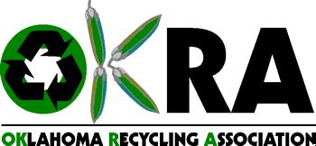 | 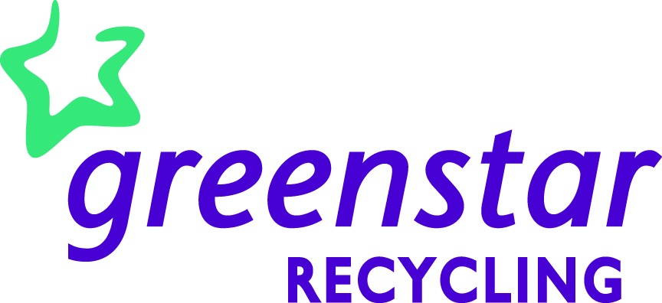
Oklahoma Recycling Association
2012 Public Service Announcement Contest
RULES
What is the OKRA Public Service Announcement Contest?
The OKRA Public Service Announcement (PSA) Contest is devoted to raising awareness about the importance of recycling in Oklahoma. The OKRA Public Service Announcement Contest gives students the opportunity to express themselves in positive manners and provide education and support to their peers through the development of original and compelling PSAs about recycling issues.
What is the theme for the Oklahoma Recycling Association Public Service Announcement Contest? The theme is “Really? Don’t trash it, Recycle It!”. The OKRA Public Service Announcement Contest invites students to submit ideas for public service announcements that encourage recycling in their schools and communities with emphasis on how recycling saves natural resources and energy and reduces pollution.
Who can enter?
Students in grades 9 to 12 can submit entries for consideration to the Oklahoma Recycling Association Public Service Announcement Contest.
How should the PSA be submitted for entry?
Entries must be at least 720p, but preferably 1080p, in QuickTime/MOV, WMV, MPEG or AVI format. Entries should be sent through the mail and will contain:
- Two (2) legible copies of the script
- Two (2) DVDs containing the audio-visual PSA
- Entry Form for each participant with one name chosen as the group’s spokesperson
- Completed Talent Release Form for each participant
- Parent Entry Waiver if participant is under 18 years of age
Entries must be postmarked by Wednesday, October 31, 2012. Send entries to:
Public Service Announcement Contest
OES Material Recovery
Attn: Chris Feeney
730 S. 9th St.
Enid, OK 73701
How will PSAs be judged? Who will judge?
Entries will be judged by a panel of individuals, including professionals in the media and broadcast industry as well as the recycling industry. Refer to the judging rubric for more details.
How will the winners be announced?
Winning entries will be announced by the Oklahoma Recycling Association on America Recycles Day, Thursday, November 15, 2012. Please check the Oklahoma Recycling Association Website to view the winners. www.recycleok.org
Can participants use other people's material?
Entries must contain all original material (including music, images, etc.). Do not submit a video that has been submitted elsewhere. Do not use trademarked, copyrighted, or otherwise branded materials, logos, products, etc. except for OKRA’s in your video.
Can I use real-life experiences?
Yes, the Oklahoma Recycling Association Public Service Announcement Contest encourages people to share their true stories. Depending on the nature of the PSA, students may be asked to submit additional waivers that give express permission to use photographs, names, and/or other pertinent material in the PSA.
What are the prizes?
Thanks to OG&E and Greenstar, each correctly submitted entry will receive a $25 award for participation. Additional prizes will be awarded to 1st, 2nd and 3rd place winners. The prizes are as follows:
o 1st place - $500.00 to the individual winner or winning group, $100.00 to the winner’s school and possible airing of the winning PSA on television stations throughout the state of Oklahoma (depending on the quality of the winning entry)
o 2nd place - $300.00 to the individual winner or winning group, and $50.00 to the winner’s school
o 3rd place - $150.00 to the individual winner or winning group, and $50.00 to the winner’s school
Will entries be returned?
No. Entries become the property of the Oklahoma Recycling Association and may be used for future promotional materials.
Does it cost anything to enter the Oklahoma Recycling Association Public Service Announcement Contest?
There is no charge for submitting an entry to the Oklahoma Recycling Association Public Service Announcement Contest.
Can I submit more than one entry?
Yes.
Can entries be disqualified?
Entries will be disqualified if they contain vulgar or inappropriate content, are not turned in with all proper paperwork, have postmarks later than the specified due date, or use copyrighted/trademarked material without written permission. Completed forms must be turned in with entries as described or the entry will be disqualified. Completed release forms are imperative.
Can adults assist in production?
Adults may assist with production, but they are limited to only verbal guidance. Adults are allowed to be actors, but not content contributors.
How many students can work on one PSA?
There is no limit to the number of students who can work on a PSA. The PSA must be entered under one name, and there will only be one prize awarded for the winning PSA. Participants can choose to divide the prize on their own terms if applicable.
What is the deadline?
All entries must be postmarked no later than Wednesday, October 31, 2012.
What does each entry need to include?
Entries should include the video, proper registration forms, waivers, compliance statements, and releases. Also, entries must include a complete script.
May it be a silent movie with a background song?
Music and sounds may be used, but they can’t be copyrighted. See the Student Release and Waiver form for complete details.
For questions not answered here, contact Chris Feeney, Oklahoma Recycling Association Public Service Announcement Contest Coordinator, at Chris.Feeney@okdhs.org.

Oklahoma Recycling Association
Public Service Announcement Contest
TALENT RELEASE FORM

Talent Name: ____________________ Project Title: ____________________________
I hereby consent for value received and without further consideration or compensation to the use (full or in part) of all ideas, videos, and/or recordings, and/or written extraction, in whole or in part, of such recordings or musical performance for the purposes of illustration, broadcast, or distribution in any manner. I agree to indemnify OKRA for any claim, demand, judgment, or other allegation arising from my violation of trademarks, copyrights, or other legally protected interest in any way in this video.
at __________________________ |  | on ________________________
(Recording Location) |  | (Date)
by __________________________ |  | for ______________________________
(Producer) |  | (Producing Organization)
Talent's signature__________________________________________________
Address ________________________________ City _____________________
State ____________________ Zip code _____________
Date ____/____/____ Age _______________
__________________________
If the subject is a minor under the laws of the state where modeling, acting, or performing is done:
Legal guardian _________________________ ___________________________
(sign name) (print name)
Address _____________________________ City ________________________
State ______________________ Zip Code ___________
Date: ____/____/____

Oklahoma Recycling Association
Public Service Announcement Contest
ENTRY FORM

This entry form must be completed by each student in each group and must be signed by each student, the student’s parent or guardian (if under 18), or the team will be disqualified. See official rules for entry at http://www.recycleok.org/psa-contest.php.

Entries must be postmarked no later than Friday, October 31, 2012.

Entry title: ________________________________________________________________
School: ___________________________________________________________________
Length of video: __________________
Sponsor: __________________________________________Telephone:_______________
Sponsor email address: _______________________________________________________
Team members: ________________________________ Grade: ___________ Age: ______
Team members: ________________________________ Grade: ___________ Age: ______
Team members: ________________________________ Grade: ___________ Age: ______
Team members: ________________________________ Grade: ___________ Age: ______
Group Spokesperson: _________________________ Grade: ___________ Age: ______
Address: _____________________________________________City:_________________
Zip: ___________ Telephone: ___________________ Email: _________________________

I certify that the above information has been filled out accurately and to the best of my knowledge. I understand that by submitting this entry into the Oklahoma Recycling Association Public Service Announcement Contest, I am giving the Oklahoma Recycling Association the right to release my video. I understand that once submitted my video immediately becomes the sole property of the Oklahoma Recycling Association. I also understand that the submitted entry packet will not be returned. I certify that my team and I completed the major tasks of writing, recording and producing the commercial submitted for competition.

Student’s name: _____________________Signature: ________________________________

Parent’s name: ______________________Signature:_________________________________

Oklahoma Recycling Association
Public Service Announcement Contest
PARENT ENTRY WAIVER

Instructions:

Parents and/or legal guardians, please read this consent form and the enclosed contest rules carefully. If you wish to give consent, please complete and sign this form, and have your child include it in his/her entry packet for the Oklahoma Recycling Association Public Service Announcement Contest. Please note that submissions that are not accompanied by properly signed and completed waivers and any other necessary information or materials will not be accepted by the Oklahoma Recycling Association.

I, ____________________________, am the lawful custodial and/or non-custodial parent/legal guardian of: _______________________________. My child has my consent and permission to:

□ Enter and participate in the Oklahoma Recycling Association Public Service Announcement Contest, sponsored by the Oklahoma Recycling Association.

□ Allow the child’s name, age, grade level and school to be displayed along with their video.

□ Participate in any media or promotional events, including any possible winner ceremonies, media interviews and publicity events related to the Oklahoma Recycling Association Public Service Announcement Contest.

Privacy Disclaimer:

Any personal information collected during the course of the Oklahoma Recycling Association Public Service Announcement Contest by the Oklahoma Recycling Association will only be used for administering this competition, or as otherwise set out in the enclosed contest rules. Except where prohibited by law, participation in the Oklahoma Recycling Association Public Service Announcement Contest constitutes the child’s and his or her parent’s/legal guardian’s consent to the storage, use and disclosure of the child’s entry details as set out in the enclosed contest rules.

I understand that upon submission, my child’s entry packet and video becomes the sole property of the Oklahoma Recycling Association, and no submitted entry packets will be returned.

X___________________________________________________ Date ___________________
Parent/Guardian signature

Judging Rubric
Category | 4 points | 3 points | 2 points | 1 point
Content | Content is original, accurate, and interesting. Topic is well-addressed. | Content is accurate and addresses topic adequately. | Content is accurate, but does not adequately address topic. | Content is not accurate  and the topic is not  addressed
Persuasiveness | Entry covers the topic with details and/or examples.  Presentation is realistic and compelling. | Entry includes important knowledge about the topic. Presentation is realistic and compelling. | Entry includes essential information about the topic, but has a few factual errors. Presentation is mostly realistic and compelling. | Entry has several factual errors.  Presentation is unrealistic.
Creativity | Entry shows original and creative ideas. | Entry has some original thought, shows some new insights. | There is little original thinking. | There is no original thinking.
Technical Production | The message is conveyed through appropriate tone and/or voice. The recording is clear. All elements coincide with the entry’s message. | The message is mostly conveyed through appropriate tone and/or voice. The recording is clear. All elements mostly blend with the entry’s message. | The message is mostly conveyed through appropriate tone and/or voice. Most of the recording is clear. Some elements tend to distract from the entry’s message. | The message is not conveyed through appropriate tone and voice. Recording is not clear. Elements distract from the entry’s message.
Overall Presentation | Entry has  excellent use of  setting, light, color,  graphics, effects,  sounds, etc. | Entry uses good  lighting, setting,  color, graphics,  effects, sounds, etc. | Entry uses good lighting, setting, color, graphics, effects, sounds, etc., but may digress from the overall presentation. | Entry use of light, setting, color, graphics, effects, sounds, etc. are distracting.

